Application to the 2023 U.S. DOT Reconnecting Communities and Neighborhoods (RCN) Discretionary Grant Program

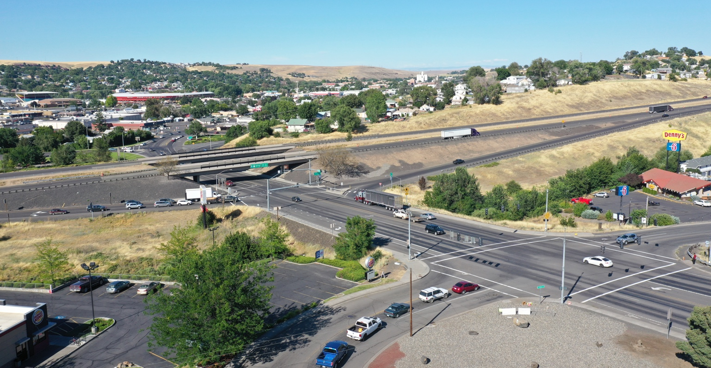
I-84/US 395 Southgate Interchange Improvements Project

Project Title: I-84/US 395 Southgate Interchange Improvements Project
Location: City of Pendleton, Oregon
Category: Neighborhood Access and Equity (NAE) – Capital Construction
Urban/Rural: Rural
Disadvantaged: Yes – Census Tract 41059950600 under CEJST
Project Type: Road; Pedestrian – Bicycle
Applicant: City of Pendleton
Applicant Type: Unit of Local Government
RCN Request: $39,750,000
Non-Federal Match: $2,250,000 (5%)
Additional materials also available on the project’s supporting materials website.

Table of Contents

Overview 1
Location And Map 3
Response to Merit Criteria 7
Equity and Environmental Justice 7
Analysis of Historic Policies 7
Exceeding the Requirements of the Uniform Relocation Act 8
Project Considerations and Mitigating Construction Activities 8
Access 8
Transportation Options to Daily Destinations 8
Safe Accommodation for All Users and Community Integration 10
Encourage Thriving Communities 10
Existing Feasibility Studies 11
Facility Suitability 11
Removes Barrier to Access, Mobility, and Economic Development 11
Addresses Environmental Burdens 12
Resolves Transportation Network Vulnerabilities 12
Improves the Movement of Goods 13
Community Engagement and Community-based Stewardship, Management, and Partnerships 13
Engaging with Local and Regional Partners including Underserved Communities 13
Engaging with Local and Regional Partners including Underserved Communities 15
Equitable Development 15
Climate and Environment 17
Reducing Transportation-Related Pollution 17
High Quality Choices for Lower-Carbon Travel 18
Consistent with Climate Action Planning 18
Project Designs to Protect the Environment 19
Workforce Development and Economic Opportunity 19
Good-Paying with Free and Fair Choice to Join Unions 19
Inclusive Economic Development and Entrepreneurship and High-Quality Workforce Programs 20
Project Readiness: Environmental Risk 20

Overview

Summary
The City of Pendleton, in partnership with the Oregon Department of Transportation (ODOT), is requesting $39,750,000 in Reconnecting Communities and Neighborhoods (RCN) funds toward a total $42,000,000 cost to complete the I-84/US 395 Southgate Interchange Improvements Project. This project will reconstruct the Southgate Interchange along Interstate 84 (I-84) to connect rural disadvantaged communities currently divided by a federal interstate and state highway, while addressing significant safety concerns stemming from the current design of the interchange. Completion of this project, which is based on the City and State of Oregon’s adopted I-84/US Highway 395 (US 395) Interchange Area Management Plan, will transform the interchange from an obsolete facility that has outlived its service life and design capacities into an asset that will provide safe, efficient access for people and freight in rural eastern Oregon.
Converging at the Southgate Interchange in Pendleton, I-84 is the most important east-west freight route in Oregon and US 395 (Southgate) is a major regional north-south freight route serving eastern Oregon. However, the construction of I-84 in the 1960s created a major barrier for access between downtown Pendleton and the residential and commercial areas of the city. While the Southgate Interchange is responsible for facilitating freight movement and local access through each of these corridors, its current design has long failed to meet traffic demands and provide safe access for the community. Options for bike and pedestrian traffic are extremely limited and high traffic flow and topographical challenges create hazardous vehicle backups onto the interstate and along the highway.

Grant funding will address these issues by reconstructing the interchange on the north side of I-84 between Southgate (US 395) and connecting roadways that provide access to and from highly used westbound lanes of the interstate. Improvements will include a separate bike and pedestrian path, as well as ADA-compliant sidewalks and sidewalk ramps and bike lanes in areas that currently have none. The project would also extend an existing local street southeast of the Southgate Interchange for local users that can only cross the barriers of US 395 and I-84 by traveling inefficiently northward through the intersections of the interchange. The extension of roadway, bike lanes, and sidewalks on this street will also enable the construction of severely needed housing by creating access to approximately 100 acres of undeveloped residential zoned land.
While this project qualifies for a 100 percent federal match under the Neighborhood Access and Equity (NAE) program criteria, the City of Pendleton is contributing $2,000,000 with an additional $250,000 from Umatilla County, for a total of $2,250,000 in collective matching funds to make this severely needed proposal a reality.
Southgate Interchange viewed from the south during non-peak hours
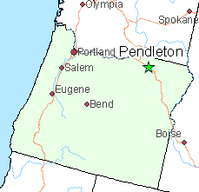
Community Background
The I-84/US 395 Southgate Interchange Improvements Project is located entirely within the rural community of Pendleton in eastern Oregon. The project will address a significant infrastructure impediment inherited by the community when the federal interstate was laid with a flawed design through the middle of the city in the 1960’s. While the interstate provides a vital commercial thoroughfare and enhanced access to the City of Pendleton, its construction created a physical barrier between north and south sides of the city. The size of the local community and use of the interstate have increased significantly since I-84’s initial construction. As a result, the misguided topographical location and design path of the interstate and interchange has left the city with a significant physical barrier separating residents on the north and south sides of the interstate from essential services, employment centers, commercial areas, and regular daily destinations.

With a population of 16,810, the City of Pendleton is the county seat of Umatilla County in eastern Oregon. Including the Confederated Tribes of the Umatilla Indian Reservation adjacent to Pendleton, Umatilla County is home to approximately 80,500 people spread throughout a vast land mass over 3,200 square miles. The area economy is primarily based on irrigated high-value agriculture.

The City of Pendleton is a small, rural community with limited funding resources, and has struggled to rebound and recoup opportunities lost during the Great Recession amidst ensuing hardships from flooding and the COVID-19 pandemic. The entirety of the project is located within a Historically Disadvantaged Community (HDC) (Census Tract 41059950600) designated under the Climate and Economic Justice Screening Tool (CEJST) due to its high percentage of low-income households and high percentage of people without a high school diploma. Additionally, adjacent Census Tracts 41059950700, 41059940000, 41059950400, which lie northeast of the project area, are also CEJST HDC’s and will directly benefit from completion of this project. I-84 provides direct access to these areas with much of the traffic utilizing the Southgate Interchange when traveling from areas in the rest of the city.

The city also experienced two catastrophic flooding events in recent years that had an enormous impact on the local community. The most recent flooding event of the Umatilla River in February of 2020 received a Presidential Major Disaster Declaration. Nearly 400 buildings were damaged or destroyed and many residents were unable to return to work due to the impact to local businesses. Nine businesses in the area suffered significant losses, two of which are larger manufacturers employing a total of 360 people. Many smaller businesses that were affected lacked flood insurance since their facilities were outside the 100-year flood plain.

Federal investment in this project will achieve a generational change by reconnecting separated communities, opening opportunities for residents most in need. In addition to increasing access and mobility for both motorized and nonmotorized travelers within this disadvantaged community, the project will enhance the safety of the local community and outside passenger and freight traffic traveling through Pendleton by addressing dangerous backups resulting from current limitations of the interstate and Southgate Interchange. Overall, the project will significantly improve safety, economic opportunity, and quality of life for residents in Pendleton’s rural community and neighboring areas.

Moreover, the project will enhance access between the City of Pendleton and the neighboring Confederated Tribes of the Umatilla Indian Reservation (CTUIR). As described later in the evaluative criteria, the project will increase safety and mobility for CTUIR’s transit service and members of CTUIR who live in the City of Pendleton. Many CTUIR individuals reside within the City of Pendleton, including an estimated 25 percent of the CTUIR workforce.

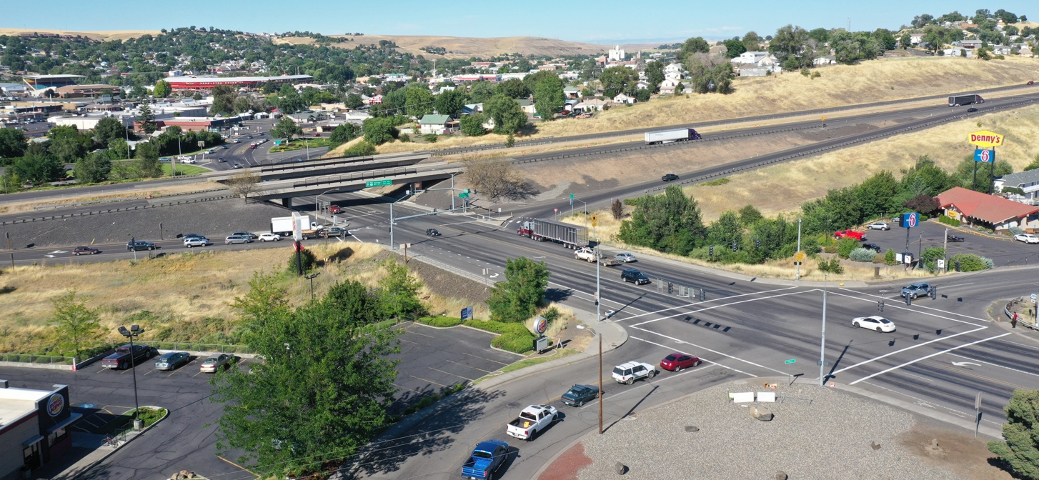

Location And Map
Pendleton is located directly along U.S. Interstate 84, Oregon’s most important east-west freight corridor. The Southgate Interchange connects the interstate with US 395, a statewide highway and freight route serving vast rural areas south of Pendleton. While these two highways provide beneficial traffic and access to and from Pendleton, the design inherited by the City from the federal overlay in the 1960’s represents a major logistical and economic obstacle for the City’s growth. The Southgate Interchange is located at the center of Pendleton and is the critical connection for the north and south sides of the community that are divided by the freeway.

US 395 (Southgate) approaches the City from the south and becomes a five-lane facility as it travels through the I-84 interchange towards the downtown center of the City. The existing interchange design forces traffic of Southgate through a narrow valley underneath the interstate, which severely limits capacity and options for diverting traffic. On the north side of the interstate, Southgate transitions into a couplet facility comprising SW Frazer and SW Emigrant Avenues. Much of the traffic flow in this area is focused on the SW Emigrant Avenue/SW 20th Street intersection, with traffic coming to and from the couplet of SW Court Avenue and SW Dorion Avenue and US 30 (Westgate Avenue). This couplet provides access to downtown Pendleton including the majority of common destinations for employment and services in the community.

On the south side of the interstate, Southgate Avenue provides connections to residential and commercial areas, before continuing southward as US 395 toward communities in the central and southern areas of the state including the cities of John Day and Burns. This highway is a vital freight corridor for the transportation of timber, lumber products, agricultural goods, and additional freight shipments to and from the region. Before exiting the City of Pendleton, Southgate provides access to St. Anthony Hospital, a federally designated critical access hospital that services its rural region of northeast Oregon as the only hospital within a 28-mile radius. The hospital is located south of the interstate directly on Southgate near other medical facilities such as Eastern Oregon Orthopedic, Pendleton Primary Care Clinic, and Interpath Laboratory which provides medical lab testing for medical centers all throughout Oregon, Washington, and Idaho.

SW Perkins Avenue connects to Southgate south of the primary interchange, providing a connection to residential areas to the southeast. Nearly 100 acres of unused, residential-zoned acreage lie along the proposed extension. As shown in the map below in orange, the project would extend SW Perkins Avenue east to connect to Tutuilla Road, which flows through Southgate Interchange and is the only connection for southeast Pendleton areas west of Southgate/US 395. This additional east-west connection would reconnect communities south of the Interchange and alleviate pressure on Southgate Interchange by providing the southeast area of Pendleton a more direct route south of the interchange, connecting businesses, homes, a fire/ambulance station, St. Anthony’s Hospital, the middle school, and sorely needed residential zoned areas that cannot be developed without such an access road.

Without the Perkins Avenue extension, local traffic will continue to funnel north through the interchange because the only other east-west connection lies several miles to the south. No additional freight traffic would be generated along Perkins Avenue since it would serve only local destinations, and steep topographical conditions make it a nonsensical freight route (see contour lines above). Instead, freight trucks would continue traveling along Southgate/US 395 and through the interchange with greater efficiency from the reduction in local traffic.

Project Components
The project consists of two major components, which have independent utility but complement each other to provide the greatest benefit if constructed together.

Interchange Improvements
RCN funding will support reconstruction of the interchange on the north side of I-84 between Southgate (US 395) and connecting roadways that provide access to and from highly used westbound lanes of the interstate. The project will relocate the existing on- and off-ramps from a non-signalized intersection to a new signalized intersection aligning with US 395 and all local streets, widen state and local streets, implement signalized intersection and capacity upgrades for a local intersection, and provide access control to state highway and local streets. The project also improves safety and facilities for all modes of transportation through the interchange area by adding a separated bike and pedestrian path, as well as ADA compliant sidewalks, raised cut-through islands, 56 sidewalk ramps, and signal push buttons. Bike lanes will also be added to side streets that currently have none.

As a result, traffic will flow freely to and from downtown Pendleton along Southgate (US 395) and arterial roadways, while on- and off-ramp improvements to a signalized regulated intersection will eliminate current safety hazards from congestion backups of freight and passenger vehicles onto the interstate.

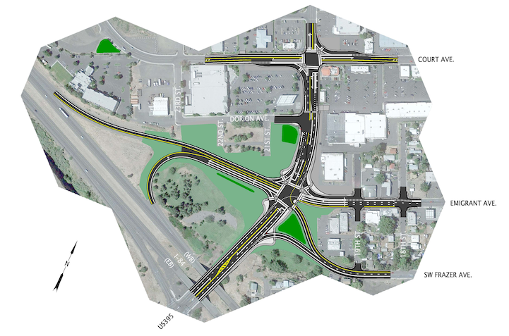
Perkins Road Extension
Southgate Interchange Improvements on North Side of Interstate 84
The second component of this project would extend SW Perkins Avenue, an existing local street southeast of the Southgate Interchange. Currently, local residential traffic from the southeast area of Pendleton can only reach daily destinations by traveling through the intersections of the Southgate Interchange. The only other east-west connection lies several miles to the south. As identified in the I-84/US 395 Interchange Area Management Plan, the extension of Perkins Avenue to Tutuilla Road would provide an alternative, more direct east-west connection for community traffic, helping alleviate pressure on the interchange. This extension will offer a complete, alternate route for the southeast area of Pendleton, which currently can only reach other destinations by traveling through the Southgate and Tutuilla Road intersection directly south of the interchange.

An extended SW Perkins Avenue will also provide new access to existing developed areas and approximately 100 acres of undeveloped residential zoned land needed for additional homes. New access to these undeveloped areas will help address challenges to expand the local housing supply, which is severely limited and a major obstacle to local economic growth in this rural community. This need was exacerbated by a recent flooding event that damaged or destroyed hundreds of local homes.

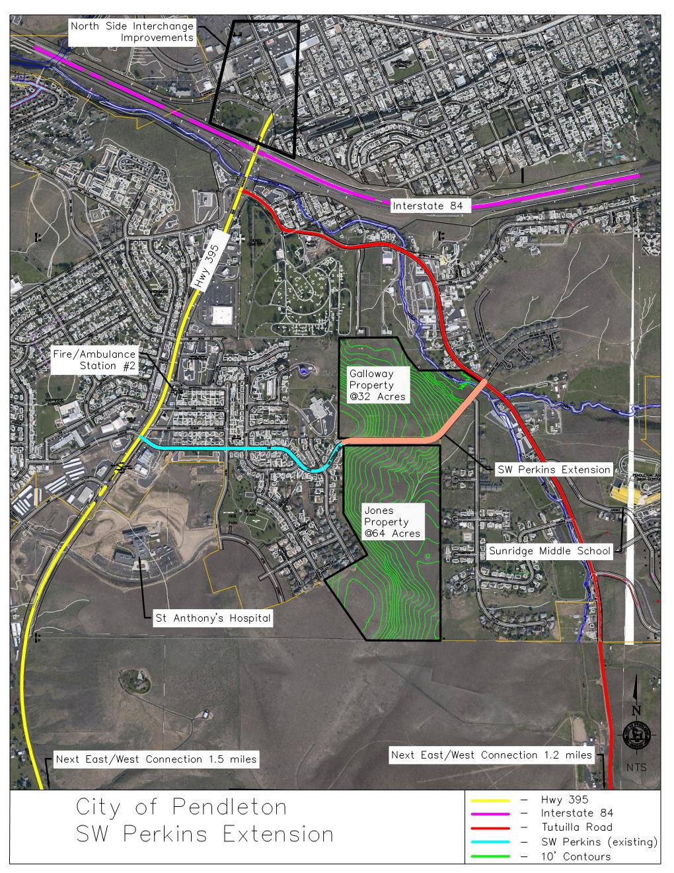
While the project will enable the addition of new homes to this undeveloped area, the extension of Perkins Avenue will remove this additional traffic, along with existing residential trips, from Southgate Interchange by offering a more direct route south of the interchange. No additional freight traffic will be generated or diverted through Pendleton’s residential areas under the Perkins Avenue extension because Southgate/US 395 will continue to offer the most direct access to the Southgate Interchange and I-84. Instead, freight traffic will flow more efficiently through the improved infrastructure and reduced local traffic of the Southgate Interchange. Altogether, this component will extend the efficiency and useful life of the interchange.
*All maps are also available as attachments to this application as “Maps” or on the additional materials website

Scalability
Although public benefits would be maximized by completing the entirety of the project, Pendleton understands that RCN grant funds are limited. In the event that US DOT has insufficient funds to award the full amount requested, Pendleton would be able to move forward with a reduced project scope scaled to $20,000,000, which would streamline improvements to the north side of the Southgate Interchange. A rendering of this concept is available on the project website. While this concept would not achieve the full benefits of the preferred design from the IAMP, it is still consistent with the IAMP and would provide significant access improvements for disadvantaged communities divided by the interstate. This scaled back option would also remove the Perkins Avenue extension component from the scope of work. While the Perkins Avenue extension is important for access, long-term functionality, and local residential and economic growth, completion of interchange improvements would still achieve significant benefits outlined in the application.

Response to Merit Criteria

Equity and Environmental Justice

Analysis of Historic Policies
Completion of the I-84/US 395 Southgate Interchange Improvements Project will reconnect a designated historically disadvantaged community divided by the interstate and enhance both vehicular and non-vehicular access to daily destinations. When the federal highway system was constructed in the 1960’s, Interstate 84 was constructed directly through the center of Pendleton’s rural community. While the interstate facilitated access to and from Pendleton for its residents, visitors, and freight shipments, the highway created major logistical challenges for Pendleton’s economic growth.

Many of Pendleton’s major employers are located north of the interstate and separated from large residential areas to the south. Traveling to employment opportunities requires most Pendleton residents to commute through the Southgate Interchange area or travel significant distances to the east or west of the interchange to avoid its congestion delays. The existing interchange design inherited by Pendleton funnels traffic through a narrow underpass below a bridge supporting the interstate, resulting in severe congestion, and creating significant hurdles between residents and their access to employment. Additionally, the Confederated Tribes of the Umatilla Indian Reservation (CTUIR) and the Wildhorse Casino employ over 1,500 individuals east of Pendleton. Access in between Pendleton and CTUIR and Wildhorse Casino requires travel along the interstate, which is usually accessed through the Southgate Interchange.

In 2010, the city and the State of Oregon completed an Interchange Area Management Plan (IAMP) that provided a comprehensive analysis of the current interchange, and made recommendations for how to best reconstruct the interchange to fix its problems. The IAMP followed six key evaluation criteria, including “Environmental, Social, and Equity” to help “assess the degree to which a concept is compatible with the natural and built environment including environmental impacts and socio‐economic impacts.”
Additionally, as part of the planning process the City of Pendleton and ODOT have coordinated with the Division Office of FHWA to ensure that the project’s implementation fully adheres to all environmental and other federal laws and regulations. A project prospectus (“Environmental Prospectus”) has been completed making the preliminary determination that the project will be classified as a Categorical Exclusion (CE). Impacts to environmental justice impacts were assessed to ensure the project contributed toward these goals and avoided any adverse effects.

Specifically, demographic data for the study area and any surrounding geographic units was obtained from the US Environmental Protection Agency (EJSCREEN Report). Based on this demographic data and field visits of the project area, the prospectus found “there is no indication that EJ populations would be adversely affected by this project.” Moreover, the prospectus stated that while EJ populations may not occur in or proximate to the project area, ODOT will ensure that all populations potentially impacted by the project will be engaged in meaningful involvement above that already completed during development of the IAMP.
Finally, the project was designed in adherence with the ODOT Blueprint for Urban Design (BUD) Initiative, which seeks to align planning and design work for transportation projects by developing comprehensive design standards and guidance to address the unique needs of urban environments. The project is consistent with BUD’s effort to consider all modes of transportation including public transit, pedestrian, and bicycle, which increase transportation options for vulnerable low-income populations.

Exceeding the Requirements of the Uniform Relocation Act
Throughout the creation of the Interchange Area Management Plan, Pendleton and ODOT sought input from stakeholders to reduce the impact on members of the community, including prioritizing an infrastructure design that would limit the amount of Right of Way (ROW) acquisition required. The design of the interchange improvements will reduce displacement and also mitigate environmental and economic impacts to ensure that disadvantaged members of the community receive the largest benefits from the project.
When administered by ODOT, the I-84/US 395 Southgate Interchange Improvements Project will not only be compliant with the Uniform Relocation Act, but also exceed these requirements based on state regulations and the Housing and Community Development Act. State regulations in Oregon go beyond the requirements of the URA by further considering individuals health, safety and compensation when relocating. Further details on these requirements can be found at Oregon.Gov.

Project Considerations and Mitigating Construction Activities
The project prospectus (“Environmental Prospectus”) completed for this project assessed climate change and environmental justice impacts to ensure the project contributed toward these goals and avoided any adverse effects including noise, air quality, public transportation service disruptions, disturbances to sacred or historic sites and flood risks.

Specifically, demographic data for the study area and any surrounding geographic units was obtained from the US Environmental Protection Agency (EJSCREEN Report). Based on this demographic data and field visits of the project area, the prospectus found that “there is no indication that EJ populations would be adversely affected by this project.” Moreover, the prospectus stated that while EJ populations may not be located in or adjacent to the project’s construction zone, ODOT will ensure that all populations potentially impacted by the project will be engaged in meaningful involvement above that already completed during the development of the IAMP. As stated in the prospectus, “Outreach and engagement would focus on relaying the project’s effects to and getting input from the community about project impacts, particularly regarding mobility and access impacts during construction...to implement a robust public engagement effort.”

Access

Transportation Options to Daily Destinations
Whether residents of Pendleton live on the south or north side of the interstate, they must travel through the Southgate Interchange to access jobs, health care, stores, and other frequent destinations and essential services. However, residents often face traffic delays due to congested traffic in the interchange. Some residents are forced to travel further east or west to reach other interstate crossings to avoid these delays. Reconstruction of intersections on the north side of the interstate, as well as the extension of Perkins Avenue, would drastically increase access for local residents traveling toward or away from connector roads to the downtown core of Pendleton, allowing residents to freely travel throughout the city and efficiently reach their destination without having to avoid congestion from the interstate.

The project will be especially beneficial in expanding access to health care. Pendleton is home to St. Anthony Hospital, a federally designated critical access hospital that serves its rural region of northeast Oregon as the only hospital within a 28-mile radius. The hospital is located south of the interstate directly on Southgate near other medical facilities such as Eastern Oregon Orthopedic, Pendleton Primary Care Clinic, Pendleton Family Medicine, Pediatric Specialists of Pendleton, Pendleton Urgent Care, and Interpath Laboratory, which provides medical lab testing for medical centers throughout Oregon, Washington, and Idaho.

Ambulances and non-emergency vehicles traveling from the interstate or north of the interstate towards the St. Anthony Hospital and other nearby medical services almost always travel through the Southgate Interchange. However, the current failures of the interchange create traffic congestion that can delay these ambulances or other vehicles from reaching critical medical care when time is of the essence. The resulting improvements from the proposed project will relieve this congestion and allow vehicles to access health care and emergency medical service destinations more efficiently. Recognizing the benefits of this project, St. Anthony is a strong supporter of this application and has provided a letter of support submitted with this application in the attached “letters of support.”

Furthermore, extending Perkins Avenue would provide an alternative east-west connection south of I-84. Currently, the only east-west option is Tutuilla Road, which is just south of the interstate and would be reconstructed at its crossing within the Southgate Interchange. This new east-west connection would greatly improve efficiency by creating a new direct route to common southerly destinations, especially for existing and planned residential developments in the southeast part of the city that are forced to use the congested Southgate Interchange for virtually all traffic destinations. Sunridge Middle School is in southeast Pendleton and the high school is on the north side, while homes are dispersed on either side of the interstate. This new connection would provide buses more direct routes to homes, alleviating significant pressure on the interchange at the end of the school day (see attached letters of support from the Pendleton School District and InterMountain ESD).

The new access along Perkins Avenue will be particularly beneficial for improving the access of low-income populations. The project is located directly in a disadvantaged community designated under CEJST due to the high number of low-income homes. Sunridge Middle School, and McKay, Sherwood and Washington elementary schools are Title I schools with over 40% of their students from low-income families and the project will also serve several affordable housing complexes and a new low-income focused childcare facility.

In addition to benefits for people with disabilities or non-vehicular travelers detailed below under the “Encourage Thriving Communities” section, these improvements will also enhance access for members of the Confederated Tribes of the Umatilla Indian Reservation (CTUIR) who reside within the City of Pendleton, including an estimated 25 percent of the CTUIR workforce. Those living in the southerly part of the City regularly utilize the Southgate Interchange, especially when entering the interstate to travel east toward CTUIR. Overall, this project will enhance travel between daily destinations and jobs in Pendleton and CTUIR.

Safe Accommodation for All Users and Community Integration
Developed through an Interchange Area Management Plan centered around public input and planning coordination, the I-84/US 395 Southgate Interchange Improvements Project has been designed specifically to be seamlessly integrated within community needs, land use policies, and the unique character of the area.

Specifically, the inclusion of bike lanes and sidewalks along Perkins Avenue and improvements within the interchange will enhance public health by adding new facilities that promote forms of active transportation. Adjacent to the bike lanes on Frazer Ave is the site of a future greenspace that is currently only accessible by car. However, once the proposed project is completed, local parks will be accessible by walking, cycling and public transportation. The new and expanded sidewalks and bike lanes will increase non-vehicular mobility, enabling the local and downtown community to access work and recreation opportunities. The City of Pendleton’s Park and Recreation Department has collaborated on the proposed improvements to increase access to Sherwood Park and local walking trails.

This project will also support housing affordability by extending SW Perkins Avenue to provide new access to existing developed areas and approximately 100 acres of undeveloped residential zoned land needed for additional homes. New access to these undeveloped areas will help address challenges to expand the local stock of housing, which is severely limited and a major obstacle to local economic growth in this rural community.

Finally, as described on Page 15, Pendleton’s unique identity is shaped in large part around large events and gatherings that it regularly hosts. This includes annual events like Pendleton Round Up, which is one of the nation’s largest outdoor rodeo, as well as Pendleton Whisky Music Festival, which is the largest annual musical concert in eastern Oregon. Southgate essentially serves as the gateway to Pendleton and is used by virtually all who come to visit and enjoy our community. Providing safe, efficient, and reliable transportation access through this infrastructure is key to Pendleton’s continued health and growth.

Encourage Thriving Communities
As stated, this project was designed as part of the Oregon Department of Transportation Blueprint for Urban Design (BUD) Initiative. BUD considers all modes of transportation including public transit, pedestrian, and bicycle, which increase transportation options for vulnerable low-income populations. In line with this initiative, the project is designed to help reduce transportation cost burdens for those who cannot afford access to a personal vehicle by supporting alternate forms of transportation including transit, bike, and pedestrian traffic.

As a result, the project will improve access for pedestrians, bicyclists, and disabled individuals by creating bike and pedestrian facilities, which are currently lacking throughout much of the interchange. Improvements will support safe and reliable travel for non-vehicular traffic including 6’ bicycle lanes, 11’ wide shared-use paths. In addition to the shared use path and shorter crossing distances, there are 56 curb ramps within this project that have been designed in accordance with current ODOT Americans with Disabilities Act (ADA) standards. All these improvements will provide safer, expanded access for non-vehicular traffic and disabled populations, traveling through the interchange.

Moreover, this project will support access for Let’er Bus, which is Pendleton’s local transit service, and Kayak Public Transit, which is operated by CTUIR and is the largest rural public transportation provider in eastern Oregon. The primary transfer point for both of Let’er Bus’s fixed routes is located on Court Avenue along the northwest part of Southgate Interchange. From there, its north-east route travels directly through the two primary intersections that would be improved under this project on Court Ave and Emigrant Ave. Similarly, the Let’er Bus south-west route travels through those same intersections before continuing along Southgate underneath the interstate. The construction of the interchange improvements will allow both Kayak and Let’er Bus to enhance transit options through a more direct, safe route, boosting access for transit riders, including tribal members of CTUIR (see “letters of support” including CTUIR, Kayak, and Let’er Bus).

Existing Feasibility Studies
The Blueprint for Urban Design (BUD) Initiative seeks to align planning and design work for urban transportation projects by developing comprehensive design standards and guidance to address the unique needs of urban environments. As a BUD project, the Southgate Interchange improvement planning process considered all modes of transportation including public transit, pedestrian, and bicycle, which increases transportation options for vulnerable low-income populations.

Additionally, Oregon’s Bike Bill of 1971 and ODOT’s current Bike/Ped Implementation Plan laid the groundwork for modal shifts and reducing vehicle miles traveled. The Southgate Interchange Improvements Project will achieve both the policies and goals established in these guiding documents by supporting non-vehicular connectivity across the freeway and enhancing connections for rural residents, including low-income populations, to jobs and amenities. By creating more efficient routes for passenger and freight traffic and expanding bike and pedestrian options, the project offers an opportunity for a modal shift in freight or passenger movement to reduce emissions, reduce induced travel demand, and lower greenhouse gas emissions.

Issues with the interchange were also confirmed by an operational analysis conducted by ODOT, which found severe failures within the interchange on and off-ramps as well as adjacent intersections. At the 20th Street and SE Court Avenue intersection that would be improved through this project, the analysis showed a current Volume/Capacity (V/C) ratio of 1.46. With any score over 1.0 showing exceeded capacity, this intersection has a current Level of Service grade of F because of its inability to meet current capacity demands. Moreover, the V/C ratio is projected to reach 2.04 within 20 years, showing even worse failures if the intersection is not improved. Under the proposed improvements, the analysis showed that the V/C ratio would be dramatically reduced to a score of 0.62, which would satisfy long-term demands for this facility to improve access for the community.

Facility Suitability

Removes Barrier to Access, Mobility, and Economic Development
As mentioned on pages 9 and 10, this project will address a physical barrier to access between the north and south sides of Pendleton, which inhibits mobility and economic development. The absence of bike lanes and safe walkways for pedestrians inhibits non vehicular traffic, and forces residents to use vehicles to travel through the interchange or detour several miles around it.

Grant funding will address these issues by connecting roadways that provide access to and from highly used westbound lanes of the interstate with inclusion of a separate bike and pedestrian path, as well as ADA-compliant sidewalks and sidewalk ramps and bike lanes in areas that currently have none. The project would also extend an existing local street southeast of the Southgate Interchange for local users that can only cross the barriers of US 395 and I-84 by traveling inefficiently through the intersections of the interchange. The extension of roadway, bike lanes, and sidewalks along Perkins Avenue will also connect communities southeast of the interchange that currently have no alternate route than traveling directly through the interchange to access everyday destination throughout the rest of the city. This extension will also enable the construction of severely needed housing by creating access to approximately 100 acres of undeveloped residential zoned land.

Addresses Environmental Burdens
This initiative will improve access to ongoing brownfield redevelopment sites located north and west of the proposed project improvements. One brownfield site has contamination from organic wood chips from its time as a lumber mill. The property owner is in the process of cleaning up the organic wood chip contamination on the site, which is approximately 5.3 acres in size and zoned for Commercial Mixed Use within the City of Pendleton. The project will redevelop four additional sites containing identified hazardous materials including two underground storage tank locations, a former dry cleaner site, and a former refinery site.
The reconstructed interchange will also support ODOT’s plans to install EV charging stations in the project vicinity as a part of Oregon’s Five-year EV Charging Infrastructure Roadmap, which calls for charging stations to be built along I-84 and specifically in Pendleton. The proposed site located near the off ramp of I-84 and has been selected in a collaborative effort with ODOT to bring zero emission infrastructure currently lacking in this rural community. Additionally, the design of the interchange will increase greenspace that will be accessible to the community through all forms of transportation. After creating the IAMP in 2010, the City of Pendleton and ODOT have enhanced the design to reduce the amount of asphalt required and will use low carbon forms of construction goods to mitigate the environmental impacts of the project.

Resolves Transportation Network Vulnerabilities
The Southgate Interchange is currently failing to provide a safe, efficient means for freight and passenger vehicle transportation between I-84, US 395, and area traffic from roads that are forced to funnel through the interchange to access the opposite sides of Pendleton separated by the interstate. Without completion of this project, problems for freight and area traffic will only worsen.

Vehicles face significant delays due to failures of the interchange, which prevents the transportation network from operating efficiently. Residents routinely travel significant distances to avoid the interchange, which places even more burden on residential streets. Without an extension of Perkins Avenue to provide an alternative east-west connection for area traffic, local vehicles will be forced to continue using this heavily congested interchange, further contributing to its failures.

As mentioned on Page 11, these issues were confirmed by an operational analysis conducted by ODOT, which found severe failures within the interchange on and off-ramps as well as adjacent intersections. Moreover, increased demands over the next 20 years will exacerbate these failures if the intersection is not improved. ODOT’s analysis showed that the proposed improvements would address these failures and provide the necessary infrastructure to meet long-term demands of the facility.

In recognition that reconstruction of the Southgate Interchange is the most significant transportation need within the Pendleton region, the Pendleton City Council adopted the I-84/US 395 Interchange Area Management Plan in 2010. This plan specified the need for reconstructing the interchange once traffic volume triggers were met, which have now been far surpassed. Furthermore, the Oregon Transportation Commission has amended the Oregon STIP (page 727) to include this planning and design for this project. The project is also included as an identified need in the most recent Oregon Freight Plan, which states on page H-43 that “the U.S. 395/I-84 Interchange ramps no longer meet intersection function criteria. Traffic backs up the ramps to the freeway regularly. This affects the primary entrance to Pendleton's commercial district.” Completion of the project would address this recognized vulnerability by providing long-term efficiency for the movement of freight and local travel.

Improves the Movement of Goods
Among the nearly 18,000 vehicles traveling along I-84 through Pendleton each day, ODOT estimates that 49% are freight vehicles. The Oregon Freight Plan also found that I-84 facilitates half of the industry output freight movement in the entire State. Freight trucks on the interstate carry U.S. export products west towards Pacific coast ports, while goods are carried eastbound along the interstate towards Idaho, Utah, and the rest of the country. US 395 (Southgate) is a primary state freight highway for the transportation of lumber, agricultural products, and additional goods to and from the rural areas to the south of Pendleton. The community of Pendleton and those in the surrounding eastern Oregon region are heavily reliant on natural resource industries that receive raw materials and ship products on US 395. This freight traffic utilizes the Southgate Interchange to reach its final market destination.

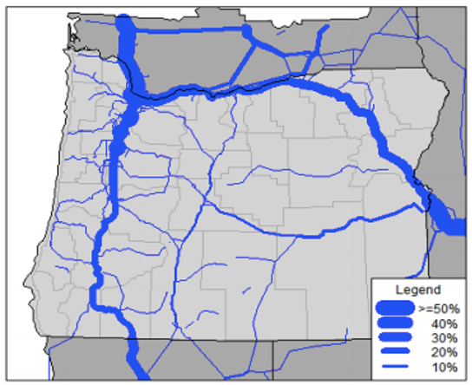
Despite its importance in facilitating the movements of goods along these freight corridors, the current state of the Southgate Interchange creates dangerous congestion backups that can delay trucks or cause collisions accompanied by extensive delays and increased shipment costs. The I-84/US 395 Southgate Interchange Improvements Project will address the congestion where these two freight corridors meet to benefit not only Pendleton, but also industries in neighboring Grant and Harney Counties, and improve regional/national freight mobility. Once complete, the I-84/US 395 Southgate Interchange Improvements Project will reduce fuel and labor costs for freight trucks by eliminating these delays and enable the long-term efficiency needed along I-84 and US 395 for the next 40 years.
Freight Value Moved Along Oregon Corridors, Pendleton noted by green arrow

Community Engagement and Community-based Stewardship, Management, and Partnerships

Engaging with Local and Regional Partners including Underserved Communities
As the top transportation infrastructure priority for the area, the I-84/US 395 Southgate Interchange Improvements Project is strongly supported by a wide base of local and regional partners including formal partnerships with Umatilla County and the Oregon Department of Transportation (ODOT). In addition to the $2,000,000 volunteered by the City of Pendleton, Umatilla County will provide $250,000 in matching funds for the project according to the budget below. As the owner of much of the transportation facilities to be improved, ODOT has provide a letter documenting their commitment to the project and willingness to administer it upon being funded.

Project Budget by Component and Funding Share
 | Total Cost | RCN Funds | Pendleton | Umatilla County
Interchange Improvements | $39,090,000 | $36,995,892.86 | $1,861,428.57 | $232,678.57
Perkins Ave. Extension | $2,910,000 | $2,754,107.14 | $138,571.43 | $17,321.43
Total Project | $42,000,000 | $39,750,000 (95%) | $2,000,000 (5%) | $250,000 (1%)

In addition to the $2,250,000 match that Pendleton and Umatilla County will contribute toward construction of the improvements, Pendleton and ODOT have already invested $3,452,553 toward the project. Both entities have committed $1,000,000 in funds for preliminary surveying and design work that is nearly complete and will enable prompt delivery of the project if awarded. Previously, ODOT completed a $1,200,000 intermediate improvement with a signalized intersection for the eastbound off-ramp. The State has also invested roughly $530,500 in survey work for the improvements on the south side of I-84 and interchanges with the US 395 Southgate corridor. Moreover, the Federal Highway Administration’s (FHWA) Division Office has already determined that the project will classify as a Categorical Exclusion (CE) under NEPA.

Because of these investments, the preliminary design work for the project will be finished before RCN funds are awarded, positioning this project for prompt delivery once funding is secured. However, due to the limited budget of the City and the funds available to ODOT Region 5 (rural eastern Oregon), this project will not be completed in the foreseeable future without federal investment.

The I-84/US 395 Southgate Interchange Improvements Project also has strong support from the local community including the following organizations that have provided letters or resolutions in support that are submitted with this application or forthcoming (see “letters of support” attached and on the supporting materials website).

- Blue Mountain Community College
- Confederated Tribe of the Umatilla Indian Reservation (CTUIR)
- Eastern Oregon Regional Airport
- Farm Supply Distributors
- Greater Eastern Oregon Development Corporation (GEODC)
- InterMountain Education Service District
- Kayak Public Transit
- Let’er Bus Transit
- Newlyweds Foods
- Oregon Regional Solutions
- Oregon Freight Advisory Committee
- Oregon Transportation Commission
- Pendleton Chamber of Commerce
- Pendleton Fire and Ambulance
- Pendleton Economic Development
- Pendleton Police Department
- Pendleton Public Works Department
- Pendleton School District
- St. Anthony Hospital
- Umatilla County
- Umatilla County Sheriff

Engaging with Local and Regional Partners including Underserved Communities
As the top transportation infrastructure priority for the area, the I-84/US 395 Southgate Interchange Improvements Project is strongly supported by a wide base of local and regional partners. ODOT and the City of Pendleton have strived to design this project with input from local residents and stakeholders to ensure it meets the needs of all users of the transportation system while taking appropriate measures to avoid adverse impacts to any neighboring properties.

In 2010, the City of Pendleton completed a comprehensive Interchange Area Management Plan that relied heavily on a public process to solicit input from community members. The city sought to involve the local community, so residents would be aware of potential designs and why certain designs may be preferred over others. As part of this process, the city held multiple open houses in addition to public hearings before the Planning Commission and City Council before the plan was adopted. Moreover, the attached financial commitment resolution for $2 million in local matching funds went before Pendleton City Council in a public forum where it was unanimously approved (“Pendleton Financial Commitment”).

As stated earlier, FHWA has completed an environmental prospectus that utilized EJ Screen and found that “there is no indication that EJ populations would be adversely affected by this project.” Moreover, the prospectus stated that while EJ populations may not occur in or proximal to the project area, ODOT will ensure that all populations potentially impacted by the project will be engaged in meaningful involvement above that already completed during development of the IAMP. As stated in the prospectus, “Outreach and engagement would focus on relaying the project’s effects to and getting input from the community about project impacts, particularly regarding mobility and access impacts during construction...to implement a robust public engagement effort.” As the project moves forward, information will be made publicly available online so residents and stakeholders can stay engaged throughout the implementation process.

Equitable Development

Creative Place-Making
This project will be completed in a way that is consistent with and protects access to local place-making. Within the off-ramp area of the interchange is a greenspace that hosts the Pendleton Cattle Drive statues, marking the area’s rich ranching and agricultural history. The view and access to this greenspace and community marker would be preserved through completion of the project.

Additionally, this project will support access to tourism and recreation opportunities in the city. Tourism is fundamental part of the City of Pendleton’s community identify and economic wellbeing. Most notably, Pendleton hosts the nationally renowned Pendleton Roundup, which is North America’s largest outdoor rodeo. The event attracts 70,000 attendees each year to the rural community, many of whom patronize such downtown restaurants and bars. Likewise, the city also hosts Pendleton Whisky Music Festival, which is the largest musical concert in eastern Oregon, and the Pendleton Bike Week, a multi-day regional event. Outdoor recreation is another key part of Pendleton’s tourism economy. National forests, wildlife refuges, and other public lands draw visitors from urban centers of the state and across the region. In eastern Oregon, this supports 4,900 jobs and a $146 million in GDP, with much of that generated in Pendleton’s Umatilla County.

To access events in Pendleton and the area’s public lands, visitors primarily drive along I-84 and/or through U.S. 395, the two highways that meet to form the Southgate Interchange. As such, Southgate essentially serves as the gateway to Pendleton and is used by virtually all who come to visit and enjoy our community. Unfortunately, this interchange regularly fails to accommodate regular levels of traffic and becomes particularly inadequate during Pendleton’s large events, causing unsafe backups onto the interstate. Completion of this project will provide safe, efficient, and reliable transportation access, which is key to supporting this vital aspect of Pendleton’s economy and the city’s continued health and growth.

Equitable Development Plans
Throughout the planning process of this project, Pendleton and ODOT have proactively addressed racial equity and barriers to opportunity dating back as far as completion of the Interchange Area Management Plan in 2010. As part of the IAMP, a central criterion was “Environmental, Social, and Equity” to “assess the degree to which a concept is compatible with the natural and built environment including environmental impacts and socio‐economic impacts.” More recently, an environmental prospectus was completed between ODOT and FHWA that assessed potential impacts to environmental justice communities (attached “Environmental Prospectus”). The prospectus found that “there is no indication that EJ populations would be adversely affected by this project.” The average of Percent Low-Income and Percent Minority for the general project area was found to be 30%, which was comparable to the city at 29%, and the county at 37%. Through project delivery, Pendleton and ODOT will ensure that all populations potentially impacted by the project will be engaged in meaningful involvement above that already completed for the IAMP.

This project represents a partnership between the City of Pendleton and ODOT, which will be the project administrator. The project would directly support ODOT’s Strategic Action Plan for prioritizing diversity, equity and inclusion by identifying and addressing systemic barriers to ensure all Oregonians benefit from transportation services and investments. Equity goals focus ODOT on workforce diversity and opportunities for advancement, expanding economic opportunities for minority groups, climate equity, and creating more representative public engagement processes. Specifically, the project would help achieve these goals by supporting transportation and economic opportunity for rural, underserved, and minority populations, including members of the neighboring Confederated Tribes of the Umatilla Indian Reservation. As stated above, equity will be a central piece to project delivery and meaningful involvement of all populations will continue to be incorporated.

Investment in Residential Development
This project is key to the residential development goals of Pendleton where expanding housing options is a critical need. The extension of Perkins Avenue will provide access to approximately 100 acres of undeveloped residential zoned land outside of the floodplain, which will expand housing options and lower costs. The City of Pendleton’s Housing Strategy zoned this land as R1 and R2 so 100 percent of it is appropriately zoned to allow duplexes, triplexes, and quadplexes as well as accessory dwelling units to address the housing strain the community is experiencing. Over the next twenty years, the City of Pendleton anticipates that approximately 900 housing units will need to be built to accommodate the growing population and creating access to the 100 acres of undeveloped land will address the housing needs of the community for decades to come.
Expanding housing options will also support long-term economic growth and opportunity for Pendleton residents, particularly those in disadvantaged communities. Employers within Pendleton have long desired to increase their number of employees only to find an insufficient labor force within Pendleton due to a lack of housing capacity. Pendleton currently has an occupancy rate of over 99%, with extremely limited opportunities for the development of new homes and rental properties. The city is confident that development enabled by this project will help provide the labor force needed for small, medium, and large employers in the area. The investment of federal RCN funds will help address these economic challenges by increasing commercial activity and opening new areas for residential and commercial development outside of the floodplain.

Climate and Environment

Reducing Transportation-Related Pollution
Completion of the project will result in greater energy efficiency and reduced emissions of the various freight and passenger uses of the interchange. Almost no new traffic will be generated by this project. Instead, by creating more efficient routes and relieving significant congestion, the project will reduce fuel consumption and its resulting harmful emissions such as VOCs, NOx, CO2, and particulate matter.

US Highway 395 is a state highway that is heavily used by trucks carrying large freight hauls including timber, wood products, and agricultural products to and from sites south of Pendleton. In addition to passenger vehicles, Southgate supports an Annual Average Daily Traffic volume of 28,100 vehicles according to ODOT’s 2019 Transportation Volume Tables (pre-pandemic). Once US 395 approaches the City of Pendleton from the south, it enters the City as Southgate where vehicles typically find extensive traffic delays due to the failures of the Southgate Interchange with I-84. These delays lead to unnecessary fuel consumption and emissions for vehicles.
Log Truck Like Those Frequently on US 395

Without reconstruction of the interchange, exacerbated delays will eventually force trucks traveling northbound on US 395 to find alternative means of accessing Interstate 84, which would draw them several miles east or west of their most efficient route. These alternative routes would result in additional fuel consumption and additional emissions from current inefficiencies. Reconstruction of the interchange would provide a reliable access point to the interstate for these trucks to use for the next 40 years.

Additionally, due to its failures, residents often travel out of their way to avoid the congestion of Southgate Interchange when accessing I-84 or the other side of the city. This requires altering their route further east or west to an access point at least a mile further down the interstate. These alternative routes are inefficient and result in increased fuel consumption and emissions. Offering a reliably efficient Southgate Interchange will enable area residents to travel along the most direct routes to access their destinations, reducing fuel consumption, and emissions by residential vehicles.

Furthermore, residents and businesses within southeast Pendleton must utilize Tutuilla Road to access north and west Pendleton as it is the only east-west connecting road to Southgate. This route takes vehicles northward to the interchange on the south side of the interstate and can be drastically inefficient for residents seeking to travel to common destinations in southwest Pendleton such as St. Anthony Hospital, Sunridge Middle School, and commercially developed areas. The proposed extension of Perkins Avenue will provide an alternate, more direct route to these areas for residents and school buses in southeast Pendleton. As a result, it is estimated that miles driven will be reduced by at least 2 miles per trip for many area destinations, lowering fuel use and emissions.
These benefits are all substantiated by ODOT and FHWA’s findings in the Environmental Prospectus, which states that “Improved traffic flow and associated reductions in congestion in and around the proposed project area are anticipated. During long-term operations, this reduction of vehicle emissions would likely result in improvements to air quality in and around the project area.” (“Environmental Prospectus”)

High Quality Choices for Lower-Carbon Travel
As described previously, the project also improves safety and facilities for all modes of transportation through the interchange area by adding a separated bike and pedestrian path, as well as ADA compliant sidewalks, raised cut-through islands, 56 sidewalk ramps, and signal push buttons. Bike lanes will also be added to side streets that currently have none, providing access for biking, walking, and rolling that does not currently exist.

Moreover, this project will support access for Let’er Bus, which is Pendleton’s local transit service, and Kayak Public Transit, which is operated by CTUIR and is the largest rural public transportation provider in eastern Oregon. The construction of the interchange improvements will allow both Kayak and Let’er Bus to enhance transit options through a more direct, safe route, boosting access for transit riders, including tribal members of CTUIR (see “letters of support” including CTUIR, Kayak, and Let’er Bus).

Consistent with Climate Action Planning
The Oregon Statewide Transportation Strategy: A 2050 Vision for GHG Reduction is the state’s roadmap for reducing carbon emissions from the transportation sector. Key actions include cleaner vehicles and fuels, low carbon modes, close proximity of housing to jobs, pricing (e.g. vehicle miles traveled charge), and demand management strategies (e.g. telecommuting). It is ODOT’s policy to pursue efforts within each of these categories statewide, and several are incorporated into the planning and project delivery of this proposal.
This project will also incorporate ODOT’s ongoing efforts to reduce greenhouse gas (GHG) emissions and achieve environmental justice. ODOT’s 2021-23 Strategic Action Plan (SAP) identifies 10 strategic outcomes. Among the agency’s highest priorities is to reduce its carbon footprint by selecting and building cleaner projects. Oregon’s climate is drastically changing with more frequent and severe wildfires, flooding, and landslides. These events can lead to road closures that impact freight, the economy, and people’s ability to obtain critical services. Improving this interchange will enhance disaster preparedness and resiliency for the area, which is at particularly high risk for flooding, wildfires, and earthquakes. This is especially important considering the large events and gatherings that regularly take place in Pendleton (Round Up, Whisky Music Festival, etc.) and to the south in Grant County. Southgate Interchange is located at the confluence of US 395/Southgate and Interstate 84, which serve as the region’s primary travel corridors. Importantly, Southgate provides the main access route to St. Anthony Hospital, a critical access hospital serving the region that would be crucial for crisis response to such an event.

Project Designs to Protect the Environment
The I-84/US 395 Southgate Interchange Improvements Project will not be constructed in an environmentally sensitive area. It has been strategically designed to avoid any wildlife habitat areas and will be constructed in full compliance with best practices to avoid any detrimental impact to the environment or endangered species. The project’s design and engineering will include stormwater mitigation, ensuring the project is constructed to prevent harmful stormwater runoff from the interchange surfaces. ODOT has already worked closely with FHWA environmental staff, which has made the preliminary determination for a Categorical Exclusion (CE). The project is not located in a flood zone and does not require a flood analysis or rise certification. It will be completed consistent with the Federal Flood Risk Management Standard.
As stated in the Environmental Prospectus, the project will “mitigate for potential short-term construction-related impacts to air quality. ODOT contract specifications require contractors to implement various mitigation measures to minimize dust and exhaust emissions from construction equipment, vehicles, and construction activities.” Like most of its contracts, ODOT anticipates the use of recycled asphalt, which will reduce the carbon footprint of the project.

Additionally, adjacent to the Southgate Interchange ODOT will be building a detention pond to mitigate the environmental impact of runoff from vehicles traveling through the corridor. Currently, runoff from transportation vehicles in the area eventually ends up in the Umatilla River which provides essential fish passage for endangered species such as the Chinook and Coho Salmon. The planned detention pond will hold and filter dangerous particulates from entering the water system and harming multiple species of Salmon that are listed as either “endangered” or “threatened” throughout areas of Oregon.

Workforce Development and Economic Opportunity

Good-Paying with Free and Fair Choice to Join Unions
The project will voluntarily be completed with adherence to the CTUIR Tribal Employment Rights Ordinance (TERO), which gives preference to qualified American Indians in all aspects of employment, contracting, and other business activities. The TERO provides that there will be at least 25% Indian employment for federal projects near the reservation. The TERO essentially serves as a labor hall and will refer employees from their offices to work on this project. TERO is designed as a notification and cooperation system with unions to target an enhanced level of union involvement in projects of this nature. The typical wage of employees on the proposed project will fall be between $60,000 - $80,000 a year, which is 2-3 times the median income in Pendleton. This will directly benefit the CTUIR members and enable wealth building for a historically disadvantaged community.

Inclusive Economic Development and Entrepreneurship and High-Quality Workforce Programs
The project will also prioritize Disadvantaged Business Enterprises (DBE) in all contracting, while also incorporating On Job Training (OJT) for workers and personnel involved in the project. As part of this project delivery, contract requirements will include apprenticeship programs and subsidization of a certain portion of OJT. Financial incursions will be instituted if those benchmarks are not met. ODOT will also deliver the project in line with federal and state wage laws, providing the higher of the two.

Project Readiness: Environmental Risk
The project is located within previously developed land and no environmentally sensitive areas are within the project area, and no significant impacts will result from the construction and operation of the project. ODOT has been working closely with Federal Highway Administration’s (FHWA) environmental staff regarding the classification, and FHWA has made the preliminary determination that the project will fall into the Categorical Exclusion (CE) classification per CFR 771.117(d)(13). See attached “Environmental Prospectus.”

Construction will take place only within the City’s developed and zoned land, so environmental mitigation measures are not anticipated. Additional environmental investigations will be completed to support the preliminary NEPA CE determination including, but not limited to Endangered Species Act consultation to address stormwater; National Historic Preservation Act Section 160 investigations for archaeological and built environment resources and tribal consultation; noise impact and abatement analysis; and a Hazardous Materials Corridor Assessment.
The City of Pendleton and ODOT will work to acquire all rights-of-way expeditiously once RCN funding is awarded, capitalizing on previous work already completed as part of the Interchange Area Management Plan. This will all be completed by 49 CFR part 24, 23 CFR part 710, and other applicable legal requirements. This project has been designed to minimize right-of-way (ROW) acquisition and impacts on residential and business displacements, including consideration of Environmental Justice populations through EJ Screen. For the necessary acquisition, ODOT and Pendleton have coordinated with those property owners and affected individuals. Owners will be offered just compensation for the required ROW. Project planning and ROW acquisition are anticipated to be completed by mid to late 2025.
The City of Pendleton and the State of Oregon have already committed $1 million in funds for surveying, preliminary right of way, environmental work, and design work that is currently underway for these improvements. As a result, the design is about 75% complete, allowing for the prompt delivery of the project. Preliminary designs, probable construction methods, and cost estimates have already been completed, confirming the project is technically feasible. Obligation is anticipated well before the September 30, 2026, obligation deadline.

Submitted with this application is a “Project Readiness: Supplemental Information” document, which provides a project schedule and additional information on the environmental readiness, technical capacity, and financial capacity of the project and its sponsors.

